Experiment VIII
Bromination of Cholesterol

Abstract:
The main aim of this experiment was to conduct a reaction of cholesterol with bromine to give a compound known as cholesterol dibromide. This reaction involves addition of a halogen a process called halogenation, to be specific I added a bromine to cholesterol. This is referred to as electrophilic reaction. First, I weighed exactly 101 mg of cholesterol and passed it through a halogenation reaction involving bromine. Secondly, I extracted 27 mg of cholesterol dibromide by the help of vacuum filtration. This amount represents a yield of 18.9%. Lastly, the melting point of the product was between 103.6 -106ºC.
Procedure:
I first used a plastic disposable pipette to measured 2 mL of MTBE solution and placed it in an Erlenmeyer flask having a volume of 10 mL. After which I weighed exactly101 mg of cholesterol and added it to the flask. I then used another disposable pipette to add bromine dropwise into the flask until a light-yellow colour persisted. In this case, I only used 7 drops of bromine. I proceeded to use a cultured tube to make the wash solution instead of using a graduated cylinder. Lastly, while using the plastic disposable pipettes again, I measured 0.6 mL of MTBE and 1.4 mL of HOAc.
Reactions:
Figure 1. Electrophilic Addition Reaction involving Bromination of Cholesterol
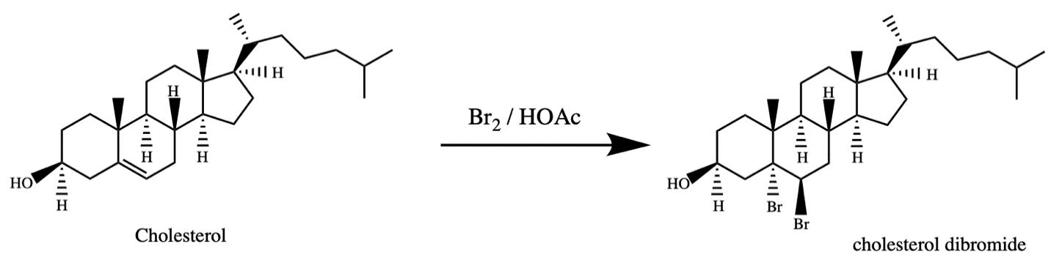
Data
Table 1. Values Recorded
Mass | Quantity (mg)
Cholesterol | 101
Weighing Dish | 416
Weighing Dish with product | 443
Temperature | Degrees Celsius (ºC)
Observed m.p | 103.6-106

Calculations
Observed Mass of product
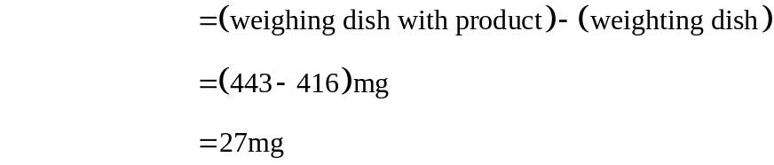
Theoretical Yield (Cholesterol Dibromide)
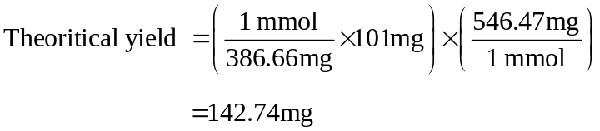
Percent Yield
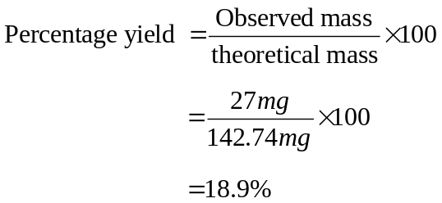
Graphs
Figure 2. A graph of Cholesterol IR Spectrum
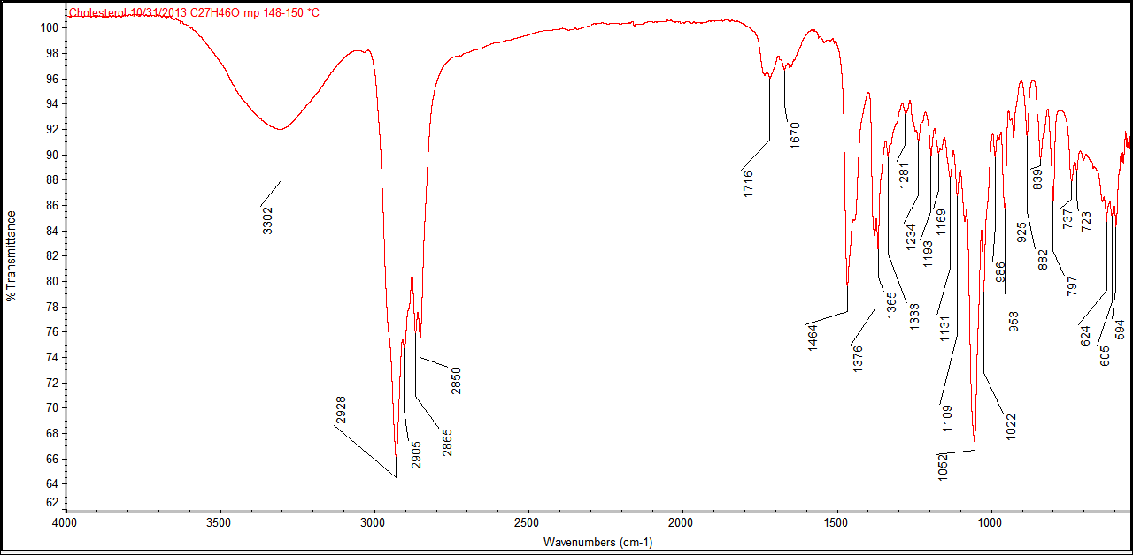
Figure 3. A graph of Cholesterol Dibromide IR Spectrum
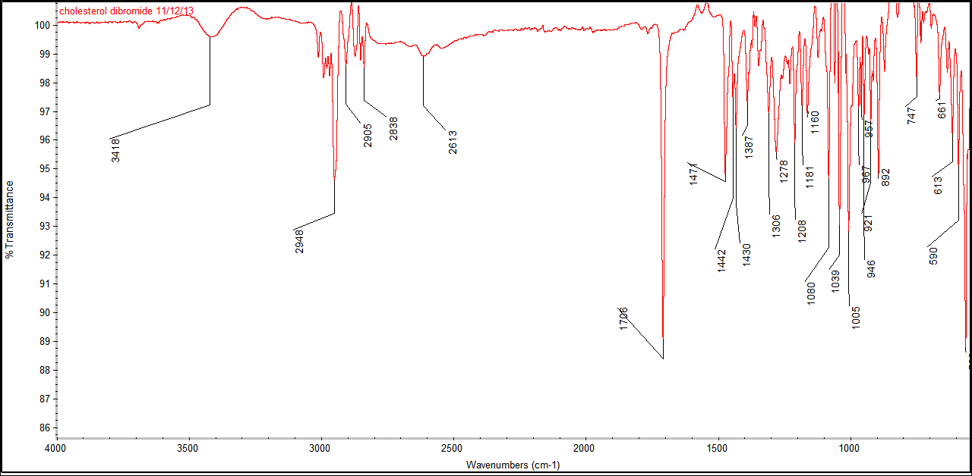
Discussion
In this practical, I first used 2 mL MTBE or methyl tert-butyl ether to dissolved 101 mg of cholesterol in the Erlenmeyer flask. The resulting mixture was reacted with bromine that was dropwise into the flask until a light-yellow color persisted. In total, only 7 drops of bromine were used after which the product cholesterol dibromide started to precipitate out as a yellowish-pasty consistency. Therefore, the precipitate was extracted by using vacuum filtration method. Two solutions, that of 0.6 mL MTBE and 1.4 mL HOAc were used to rinse the flask and at the same time act as a preservative to cholesterol dibromide. The solid was dried using filter papers after which it was scrapped off and weighed using tared aluminium weighing dish. The observed mass of the product was 27 mg. This mass represents 18.9% yield as the theoretical mass in this case is 142.74 mg. The product was then heated and melting started at a temperature of 103.6ºC and by the time the temperature was 106ºC most of the solid had melted. This temperature is close to the theoretical melting point of 105°C implying that the product from this experiment exhibited little signs of impurity.
The reaction involving the reactants is called electrophilic addition reaction. This is because a nucleophilic attacking spot was created in the 4-menbered ring cholesterol when the double bond was broken. This enabled the negatively charged bromide ions which are electrophiles to get attracted to the positively charged cholesterol.
It should be noted that any experiment must have errors. Therefore, this experiment was not an exception. This is because of the small amount of the product that was extracted. In this case, the yield of 18.9% may be due to procedural errors. Also, not all the weighed cholesterol was transferred into the Erlenmeyer flask as some remined stuck onto the paper in the process of transferring. This means that the amount of cholesterol that reacted was less than 101 mg which was used to calculate the theoretical yield. On the other hand, some of the precipitates stuck on the Erlenmeyer flask even after washing in the filtration step. This means that the weighed amount of cholesterol dibromide was less than the actual product from the experiment. Lastly, a small amount of the precipitate remained on the filter paper and was not accounted for in the experiment. Therefore, I propose that more of the wash solution to be used to ensure a high yield if the experiment is repeated either by me or by another researcher.
Regarding the IR spectrum in Figure 2, cholesterol has two functional groups. They include alkenes and secondary alcohols. These alkenes are symmetrical in nature and thus, there is little to no absorption in the spectrum. However, for the alcohol functional group, there exists a big round curve in the IR spectrum ranging from 3,300 cm⁻¹ to 3,400 cm⁻¹. These curves do not represent the carboxylic group as they are not broad.
In figure 3, the curve observed at a wavelength of 3,418 cm⁻¹ is a characteristic of the OH group. The acetic acid functional group is exhibited by the sharp peak at a wavelength of 1,706 cm⁻¹. Lastly, the series of peaks occurring from the wavelength of 2,948 cm⁻¹ to 2,838 cm⁻¹ are as a result of the carbon to hydrogen bond.

